|  |  |  |
| --- | --- | --- |
|  | | |
| **Welcome to ‘The Pulse’** | **The Pulse**  “The heart of God  to the heart of the community”  **October 2018 Issue** |

The Pulse is newsletter produced by the Ellesmere Cooperating Parish. We are three congregations that make up a rural parish in the south-eastern part of the Selwyn District of Canterbury, NZ.

Our congregations gather folk from Leeston, Southbridge, Dunsandel and Brookside, drawing people from all walks of life, with a high proportion involved in farming or associated services or retired. Our main worship centres are at St. David’s, Leeston and Trinity, Dunsandel. Our Brookside congregation has shared use of St. Luke's Anglican Church at Brookside.

**Purpose Statement:** ‘*To spread the good news of Jesus by committing ourselves to work and worship together, to love and care for one another, and to be of value to God in our community.*’

We believe that the Bible is the Holy Spirit-inspired Word of God, that Jesus Christ is the Son of God, and that he calls his church to mission locally and globally.

To find out more about the Ellesmere Cooperating Parish, please take the time to visit us on line at [www.churchatellesmere.org.nz](http://www.churchatellesmere.org.nz/)

We hope you enjoy this issue of The Pulse.

Your newsletter was delivered by:

…………………………………………………………….

Phone: …………………………..............................

**Chairman Peter Withell’s report for:**

**40th Ellesmere Co-Operating Parish Council Annual Report.**

The year started with “the need to pass on the baton”, need to emphasise Co-Operating Parish.

As a follow on from the Fellowship Day, held in July 2017, a Parish Forum was held on September 23rd 2017, followed by an additional Forum 11th November. Of most importance was the reflection on the events of the previous year. “Hopefulness” was seen as one of the positive aspects in the life of the Church, that we can focus on for the future.

The “Count me in “Membership Forms (280+ copies) were distributed to all who regularly attend Church, receive the Pulse and those who are visited by the Pastoral Care Team. The results were collated in October, so as to formally record the Parish Roll.

Sunday November 19th, A Brookside Congregational Meeting was held.

A decision to proceed with the building repairs and maintenance, in consultation with the Anglican Parish, emerged, and to continue having a monthly service, and to encourage more people from the extended Parish to attend. There was an agreement to revisit the Brookside issues and to be discussed by the Parish Council and the whole Parish at the A G M, August 2018.

The November Parish Council Meeting, was led by the Methodist Superintendent, Rev Katherine Walters, beginning with a Review of the Rev Heather Kennedy’s nine month Ministry.

Rev Katherine Walters was invited to be the Parish Advocate, through the formal “Stationing Process”, followed on by an outline of the whole process, that Rev Heather Kennedy would lead us through, during 2018, in preparation and planning for a new ministry.

Murray Doak, Robbie Stewart, Rev Heather Kennedy, Lois Birkett and Francie Baylis were given the task of rejuvenating the Parish Profile, for the January Parish Council Meeting.

In January, the Parish Profile was discussed and points for strengthening made. Murray Doak was Farewelled, a huge thankyou to Murray and Leanne for their support and input to the Parish.

The Parish Profile was completed in February.

In April the “International Rural Ministry Conference,” convened at Lincoln University, a number of participants were hosted by the Parish, pre-conference, and the Rev Eric Skilling’s, from Canada and Rev Francois Pihaatea from Fiji preached at Leeston and Dunsandel.

A group met to compile and draw up a Parish Strategic Plan, to complete our Parish preparation for Stationing.

Parish Council met with Rev Katherine Walters and the Rev Barry Ayres in February, to formulate the Parish Strategic Plan and approve the final Draft of the Parish Profile.

Treasurer Andrew Sykes, presented the Profit and Loss and Balance Sheet 2016/2017 and the Parish Budget 2017/2018.

In June the Parish/Presbyter Profiles arrived and were scrutinised by a small working group, then presented to the full Parish Council.

10th July Parish Council met again with Rev Katherine Walters and Dick Clayton, to confirm the possible four ranked Presbyters.

At the time of the AGM, The Ellesmere Co-Operating Parish, has not been successful in achieving a Stationing Match.

However, Rev Katherine Walters has a Plan B and C!!!!!!

After 12 months of negotiation with the owner of the adjacent land at the Leeston Church site, the proposed transaction was withdrawn from sale.

10th August an inspiring film “Born to Win” was shown at the Leeston Church.

Because of very light attendance at the Christmas Day Service at Leeston 2017, the Rev Heather Kennedy suggested this Service be reconsidered for 2018, including the possibility of Leeston attendees joining with the Brookside Service on Christmas Morning.

The Leeston Congregation need to identify a Health and Safety Officer.

The Parish Council is supporting the endorsement of Mandy Lotter as a Lay Preacher in training.

The Parish accounts and Financial systems are in good working order, a huge thank you to Andrew Sykes for his leadership and commitment as Treasurer/Secretary and his support to the St David’s Place committee, with respect to the changes in Financial Structure and Administering the St David’s Place accounts and combining with the Parish accounting system.

To Rev Heather Kennedy; thank you for carrying, sometimes more than your share of the load, and at times fewer ”Footprints in the Sand.”

Your energy and enthusiasm in your role as Presbyter of the Ellesmere Co-Operating Parish, is appreciated. Also your energy and enthusiasm for the wider Church, Synod, Presbytery and the Joint Regional Forum, UCANZ standing Committee and National Forum and Inter Church Chaplaincy Trust Board Meetings in Wellington to name a few.

Communication Processes and Governance issues need to be high on the Agenda for 2018-2019.

The last 18 months has been a very challenging period for the Parish and the Parish Council.

May we all find a fresh perspective and purpose in sharing and living the Gospel of Christ in our community and everyday Lives.

Peter Withell (Chairman Ellesmere Co- Operating Parish Council)

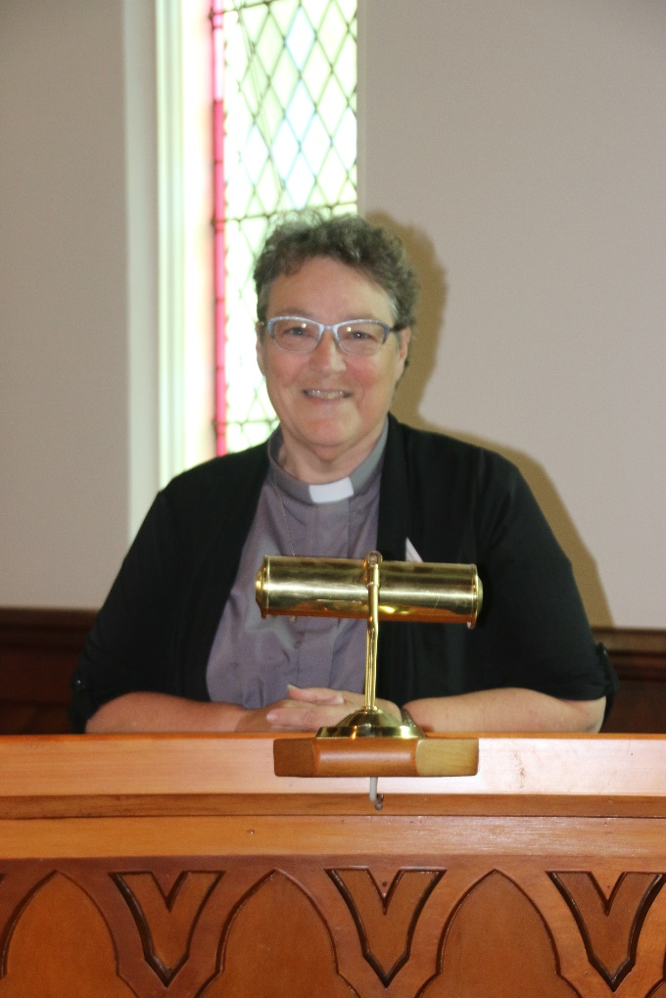**Parish Council Reports from Rev. Heather Kennedy –**

**June - September 2018**

At the end of June, Noel Dalley and I attended the Methodist Synod in Ashburton, connecting with those in attendance from parishes in the Southern part of the Synod. Fellowship over morning tea and lunch gave us time to network and connect. A major part of the meeting was the task of thinking of suitable candidates for the various committees and workgroups of Synod, finding out the roles that are undertaken by these groups and making nominations for the next year or so.

Café Church at Dunsandel on the fourth Sunday in June, was led by Mandy Lotter, who helped us think of a least ‘four ways of hearing God’s voice’ and how we can record, reflect and act on what we hear.

Mandy has been undertaking some studies on-line and is keen to further her studies. She has been accepted as a ‘Lay Preacher in Training’ under the guidance of the Lay Preachers Association, with endorsement and support from Ellesmere Co-operating Parish. Mandy has now enrolled at Laidlaw College to undertake a Certificate in Christian Studies by correspondence.

I attended a ‘Women in Ministry’ retreat at the Community of the Beatitudes in Leithfield and had lovely time in fellowship with nine other Presbyterian Women. The main task we undertook was a discussion of the content of the Women in Ministry 'Still Burning' report, to which we added some recommendations for addressing some of the issues, concerns and injustices identified in the report.

Thanks to those who organised and participated in the ‘Fish and Chips’ night, where everyone had a great time. Thank you Hilary for your interesting activity.

I attended the Regional Forum of UCANZ (JRF), in Christchurch, where I helped with the presentation of a report from the International Rural Churches Association, with feedback from the conference held in Lincoln. Thanks to Don Clearwater who provided a report for me to share, on the hosting of delegates prior to the IRCA conference.

Then I was asked by JRF to lead a discussion on ‘Why we have Parish Reviews’, which created quite a lively session.

Later that day I attended a PWANZ (Presbyterian Women) event at Cashmere Presbyterian Church, which was a worthwhile occasion (similar to the one attended by some of the women from Leeston, earlier in the day at Rakaia).

The meeting of the UCANZ Standing Committee I attended in Wellington in the first week of July, discussed the changes to the system by which parishes will determine their Supporting Partner denomination and the way they will pay their associated fees. This also brought about a discussion on the changes of the processes that are required to be undertaken if a parish wishes to leave UCANZ, dissolve their union and become a single denomination congregation. This is happening more and more, especially where there are difficulties with the ethos and theology of the co-operating denominations, and in particular with the difference between Methodist and Anglican observance / blessing of same-sex marriages and the Presbyterian ruling against this being observed.

The Presbytery Retreat at Hanmer Springs was a good opportunity for networking, relaxing (doing some knitting), a swim in the hot pools, and a guided discussion on obstacles to working towards achievable church mission goals. The discussion was led by the Canterbury University Chaplain, Rev’d Spanky Moore, a very interesting character, whose provocative and challenging concept brought about a very lively debate and some interesting discoveries.

Following on from the endorsement of Mandy Lotter as a Lay Preacher in Training, we were provided with a very well-resourced and lively service on Lay Preacher Sunday.

On Wednesday 12 July I attended the Ministerial Synod at North Christchurch, along with a number of Supernumerary Ministers. We all shared our stories and had a special session on the details of the regulations regarding minister’s stipend and allowances.

The next day Synod met for a Covenant Service, including the presentation of the Memorial Minutes (including a minute for John Withell) and then the annual business meeting and a presentation on the policy document on Climate Change that will be discussed at Conference in September.

On the Saturday of Synod, we participated in a Workshop on Mediation, which saw us all being entertained as well as challenged by the very lively consultant from Christchurch Mediation Services. We were involved in many activities which saw us all understand more about how mediation works and what it can achieve. The final session of the day was an open forum for many differing topics and sharing of upcoming activities and opportunities for parishes to attend training sessions and resource events.

In response to Noel Dalley recommending at the Parish AGM, that we be more intentional about thanking people for all the time and talents they volunteer in the life of the church, these thanks have been voiced at our worship services. Thanks also to Andrew Sykes for the provision of a substitute lap-top to be used at Trinity, following the burglary.

I accompanied Mandy Lotter for her first service in Rakaia in August and am happy to report that she is well on the way to becoming a competent and thought-provoking preacher and leader of worship. She also provided an interesting topic for the Southbridge Homegroup and will lead the next meeting in October (as I will be at Presbyterian Assembly).

We have had two Parish Forums on Saturday mornings at St. David’s and have discussed much. Most recently and following on from the Parish AGM, were discussions about the size, make up and roles of the Parish Council, with one idea being, to consider there being two representatives per congregation and reps from Worship, Property and Pastoral Committees. Also to be considered are the continuation of Brookside services, the frequency of Dunsandel services as well as the roles of Chair, Secretary and Treasurer. With the resignation of Andrew Sykes after ten years as Treasurer, which includes responsibility for reporting to the Charities Commission, it is hoped that someone could be assisted by Andrew to take on the role and learn what is required.

Other questions asked were – does the parish need to employ some-one to undertake the production of the weekly news sheets, The Pulse and with information from the Minister, the preparation of the Easy Worship slide-show for each service. The need for identifying ‘leaders-in-waiting’ was thought to be for each sector to work on, by inviting new people to serve on sector and in other volunteer roles.

I had a very busy weekend away at my mother’s for her 88th birthday and wish to thank Rev. John Titlow for leading worship at St. David’s and Rev. Don Clearwater at Trinity.

Robbie Stewart and I attended the Presbytery Review meeting at Halswell in September and contributed to this process of assessing the function and facilities of the Alpine Presbytery.

In September, St. David’s Fellowship group met at Abbeyfield for a Bible Knowledge challenge followed by an enjoyable roast dinner with Abbeyfield residents. I was lovely to feel so at home with everyone there.

Holy Communion was celebrated on Sunday 9 September and will observed be next on Sunday 14 October. I led Café Church in a Bible ‘pub’ Quiz, which explored some of the knowledge we have of the Bible and the people in it. Congratulations to the winning team.

Sunday 30 September (during Methodist Conference) the Parish Combined Service at St. David’s will host Gillian Southey from Christian World Service, and during Presbyterian Assembly, on Sunday 7 October, services at St. David’s and Trinity will be conducted by Rev. Alan Webster from Crossways Parish in Christchurch.

As you will see in the Church Diary, in the Pulse, the next Combined Services are for Sunday 23 December at St. David’s, Christmas Eve at Trinity, Christmas Day at Brookside, Sunday 30 Dec at Trinity, and Sunday 6 January at St. David’s, which is my last service in the parish. Combined services for Sundays 13 January, 20 January will be Anglican and on Sunday 27 January the service at Hone Wetere, Taumutu. The Worship Committee will be responsible for organising worship services from February on, including the Church Picnic at Killinchy.

I am looking forward to attending the Methodist Conference and Presbyterian Assembly over the next 10 days and understanding the differences between these denominational gatherings.

Following on from the outcome of the Methodist Stationing process Rev Kathryn Walters is working hard on finding a Presbyter for the parish, as well as working with a parish where I can go and provide ministry for a couple of years, before returning to Invercargill.

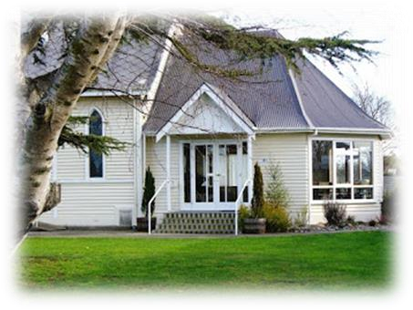***News from the Leeston Sector Group***

***-from Hilary Boal***

Nothing much to report since the Annual Report.

We had an enjoyable Film Evening in the Church on Friday 10th August when we watched “Born To Win” a very emotional story of the life of Leon Terblanche, a teacher of disabled young ones. On arriving we were treated with ice-cream slices and at the end a cuppa, all for a gold coin donation. Another film evening to be held in the future.

The Congregational Meeting was held on Sunday 12th August, to elect the Sector Members for the coming Year, the existing Members were re- elected, with exception of two that have left the Parish. Those Members being… Lois Birkett, Bev Gilbert, Kathy Steele, Hilary Boal, Janice Speirs, Jenny Heslop, Frances Baylis, Elaine Van Roon.

Rev. John Titlow and Rev. Don Clearwater conducted the Services on the 2nd September at Leeston and Dunsandel, while Rev. Heather was away and Rev. Neville Burns on the 26th August while Rev Heather supported Many Lotter who was preaching at Rakaia.

Several of our church folk have under gone surgery and we wish them a speedy recovery and deepest sympathy to those who have lost loved ones.

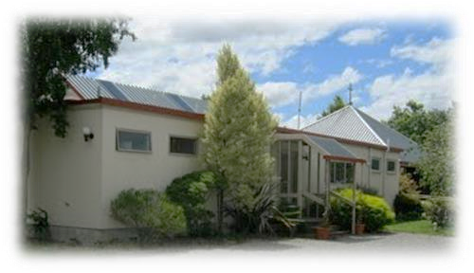***News from Dunsandel Sector group***

* ***From Jill Chamberlain***

*Winter has passed by at Trinity fairly uneventfully. Several regular members of the congregation were away in the northern hemisphere enjoying new experiences, sights and warmer climes. It has been good to see them all return safely.*

*On 15th July a combined Anglican service with parishioners from the whole parish was held. Rev’d Nelson Kennedy officiated.*

*Also on 15th July the Congregational meeting was held. Maureen Chatterton agreed to become a member of sector and she was welcomed at the sector meeting on 2nd August.*

*Trinity sector accepted the resignation of Heather Thomas, due to work commitments.*

*On August 19th after church we enjoyed a lunch of soup, homemade breads and cake. It was delicious.*

*The parish AGM was held at Trinity on 23rd August.*

*A big thank you goes to Athol Wolff for keeping the grass under control and to Murray Chamberlain for the new wheels on the tea trolley.*

*We look forward to spring.*

**News from St. David’s Friendship Group.**

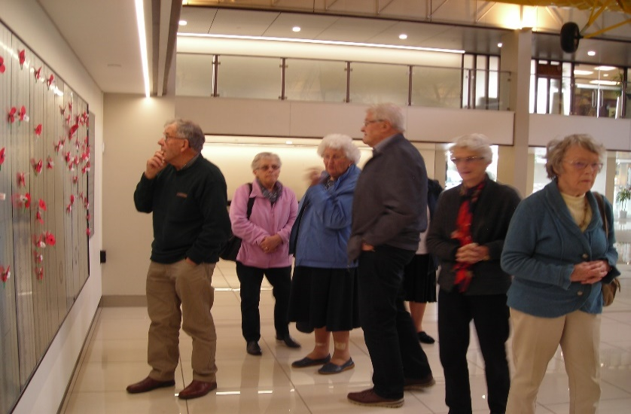Wednesday 5th September was our Friendship outing to the Wigram Airforce Museum, when 10 of us including the Drivers , Noel Dalley driving the “Ellesmere Community Van” and John Lay his car. The whole complex is huge and beautifully set out. John Lay gave us a wonderful detailed commentary as we wandered around, telling us about the many different planes, including the one he flew while in the Air Force.

The wonderful displays and write ups of Air Force life was

amazing, you could spend the whole day looking around, trying to take it all in. A big thank you to John and Noel, you were much appreciated. We left the Museum for lunch at Muffin Break at The Landing and arrived back in Leeston at 3pm, with a better knowledge of what went on years ago.

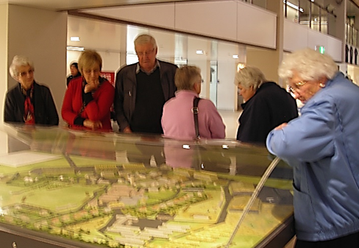

Next Month… 3rd October, 2pm. at Jan Caunter’s Home.

Speaker… Ruth Cox… from “Selwyn Cattery”

**Southbridge Home Group**

On 4th September Rev. Heather took a communion Service for seven members of our Southbridge Group. We then had an inspiring talk from Mandy Lotter. Mandy explained her studies that she is doing with the aim to become closer to teaching and preaching the Gospel. Her visual was a Power Point on our television screen which showed us some of her work.

We all enjoyed her presentation and thank her very much for her time, and for her willingness to share with us her studies over morning tea. Well done Mandy.

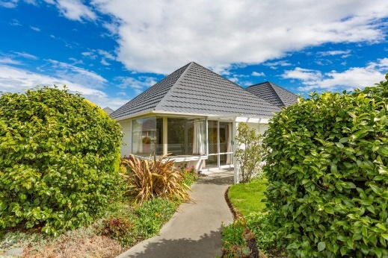‘Change of Lifestyle’

UNIT FOR SALE / or rent

5/30 High St., Leeston

Have you thought of down-sizing while you’re still active

and have the energy to do something different?

ST. DAVID’S PLACE has a home waiting for you –

to accommodate some of those ‘MUST DO’ adventures.

No lawn to mow, a small garden, friendly neighbours

and warm, sunny home that is easy to keep.

We invite you to come and have a look and make an offer to purchase.

Contact: Noel Dalley 03 324 3171

or John Lay 03 329 1617

**Our Mission Shed outreach**

Stepping out into spring the Mission Shed displays a splash of colour with its array of summer garments.

One is spoilt for choice with a good selection of affordable spring and summer clothing bringing style and choice aplenty.

The public in general continue to support us with their donations of clothing so much so that we have only half of our summer stock currently on display.

Do consider being a part of this worthwhile Ministry.

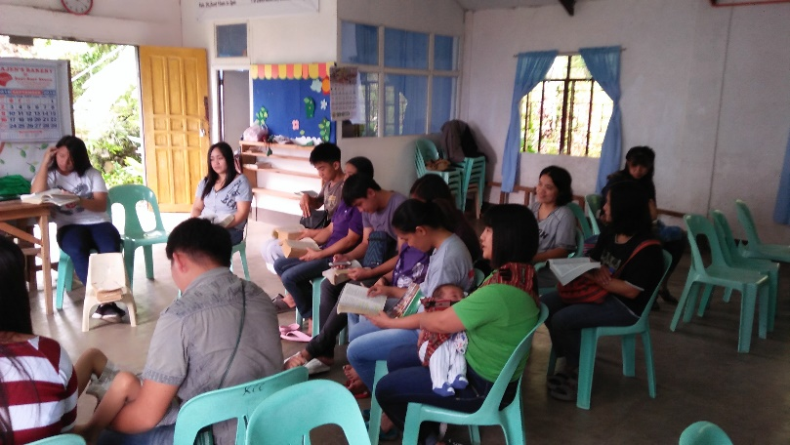Drop in for a chat, encourage those involved, pray for both Pastor Ablos and his Filipino mountain church and the Qinghai Orphanages in Hong Cong. $1500 has been sent to each of these mission projects.

Make a purchase, a donation or communicate with the world outside church doors by volunteering on the shop floor.

With the focus on Health and Safety Robbie has provided the Mission Shed with a new Dehumidifier to replace the tired old one. Our thanks to him for this generous gesture, it is very much appreciated.

It has been suggested by a member of the public that we display a ‘Watch Your Step’ notice between the two entrances since the steps are also a hazard.

A safety hand grip has been fixed to one door frame but another would be useful so if anyone has one lying around please consider donating it.

Thank you to Shirley who has kindly donated of her time allowing the Mission Shed to extend its opening hours – now open Tuesday afternoon 1-3pm as well as both Wednesday and Thursday morning - 9:30am to 12:30pm.

The purchasing for and the packing of Christmas Child Shoeboxes are underway with a good response thus far.

Currently four completed boxes have been handed in from church members along with extra fillers and monetary Project donations. The Mission Shed has completed six boxes with another two underway. A wonderful effort and as this goes to print there is still several more weeks to respond so consider blessing a child this Christmas by filling a shoebox.

As always thanks be to God for his provision, his faithfulness, and his love for in Him all things are possible.



*Recently devastating landslides caused by Typhoon Mangkhut impacted on many lives in the Philippians. Please pray for Pastor Teena, her family and the families of all in the Lifetouch Fellowship who have lost loved ones.*

*We pray for aid agencies and all those who are helping in the recovery from this tragic situation.*

***A page for the children –***

***Spring flowers remind us of God’s creation.***



***Services & Events –***

***October 2018 to February 2019***

|  |  |  |
| --- | --- | --- |
| **October 2018** | | |
| Tuesday 2 October | 9.30am | Southbridge Home Group |
| Wednesday 3 Oct. | 2pm | St. David’s Friendship group AGM |
| Thursday 4 October | 12 noon  7.00pm | Trinity ‘Lunch Bunch’  Men’s Fellowship – Leeston Library |
| Saturday 6 Oct. | 6.00pm | Lifetouch Fellowship  Anniversary Celebrations and farewell to Pastor Waldo |
| Sunday 7 October | 9.30am  11.00am  5.00pm  7.30pm | Worship Services – Pentecost 20  St. David’s, Leeston  Trinity, Dunsandel  Youth Pizza Café at St. David’s  Brookside (Anglican) Service |
| Thursday 11 October | 2pm  7.30pm | Fellowship groups  Leeston Sector meeting |
| Saturday 13 Oct. | 7.30pm | Lifetouch Fellowship |
| Sunday 14 October | 9.30am  11.00am | Communion Services – Pentecost 21  St. David’s, Leeston  Trinity, Dunsandel |
| Saturday 20 Oct. | 7.30pm | Lifetouch Fellowship |
| Sunday 21 October | 9.30am  11.00am  7.30pm | Worship Services – Pentecost 22  St. David’s, Leeston  Trinity, Dunsandel (Anglican)  Brookside (Communion Service) |
| Thursday 25 Oct. | 7.30pm | Parish Council meeting at Dunsandel |
| Saturday 27 Oct. | 7.30pm | Lifetouch Fellowship |
| Sunday 28 October | 9.30am  10.45am | Worship Services – Pentecost 23  St. David’s, Leeston  Café Church, Dunsandel |

|  |  |  |
| --- | --- | --- |
| **November 2018** | | |
| Thursday 1 Nov. | 12 noon  7.00pm | Lunch Bunch  Men’s Fellowship at Leeston Library |
| Saturday 3 Nov. | 7.30pm | Lifetouch Fellowship |
| Sunday 4 Nov. | 9.30am  11.00am  5.00pm  7.30pm | Communion Services – Pentecost 24  St. David’s, Leeston  Trinity, Dunsandel  Youth Pizza Café at St. David’s  Brookside (Anglican) |
| Tuesday 6 Nov. | 9.30am | Southbridge Home Group |
| Wednesday 7 Nov. | 2.00 pm | St. David’s Friendship group |
| Thursday 8 Nov. | 12 noon  2.00pm | St. David’s Fellowship Dinner at Manse  Trinity Fellowship Group |
| Saturday 10 Nov. | 7.30pm | Lifetouch Fellowship |
| Sunday 11 November | 9.30 am  11.00 am | Worship Services – Pentecost 25  St. David’s, Leeston  Trinity, Dunsandel |
| Thursday 15 Nov. | 7.30pm | Dunsandel sector meeting |
| Saturday 17 Nov. | 7.30pm | Lifetouch Fellowship |
| Sunday 18 Nov. | 9.30 am  11.00am  7.30pm | Worship Services – Pentecost 26  St. David’s, Leeston  Trinity, Dunsandel (Anglican)  Brookside |
| Thursday 22 Nov. | 7.30 pm | Parish Council at Leeston |
| Saturday 24 Nov. | 7.30 pm | Lifetouch Fellowship |
| Sunday 25 Nov. | 9.30am  10.45am | Worship Services – Reign of Christ  St. David’s, Leeston  Café Church, Trinity, Dunsandel |

|  |  |  |
| --- | --- | --- |
| **December 2018** | | |
| Saturday 1 Dec. | 7.30pm | Lifetouch Fellowship |
| Sunday 2 December | 9.30am  11.00am  5.00pm  7.30pm | Communion Services – Advent 1  St. David’s, Leeston  Trinity, Dunsandel  Youth Pizza Café at St. David’s  Brookside (Anglican) |
| Tuesday 4 Dec. | 9.30 am | Southbridge home group |
| Wednesday 5 Dec. | 11.30am | St. David’s Friendship Group lunch |
| Thursday 6 Dec. | 12 noon  7.00pm | Trinity ‘Lunch Bunch’  Men’s group, Leeston Library |
| Friday 7 Dec. | 5.00pm | Leeston Christmas Parade |
| Saturday 8 Dec. | 7.30pm | Lifetouch Fellowship |
| Sunday 9 December | 9.30am  11.00am  7.00pm | Worship Services – Advent 2  St. David’s, Leeston  Trinity, Dunsandel  Community Carols at Trinity |
| Thursday 13 Dec. | 2.oopm  7.30pm | Fellowship groups  Leeston sector meeting |
| Saturday 15 Dec. | 7.30pm | Lifetouch Fellowship |
| Sunday 16 December | 9.30am  11.00am  7.00pm | Worship Services – Advent 3  St. David’s, Leeston  Trinity, Dunsandel (Anglican)  Brookside |
| Thursday 20 Dec. | 7.30pm | Parish Council meeting at Dunsandel |
| Saturday 22 Dec. | 7.30pm | Lifetouch Fellowship |
| Sunday 23 December | 9.30am | Worship Services – Advent 4  St. David’s. Leeston |
| Monday 24 Dec. | 10.00pm | Christmas Eve service at Trinity |
| Tuesday 25 Dec. | 8.30am | Christmas Day service at Brookside |
| Sunday 30 Dec. | 9.30am | Combined Ellesmere Parishes service at Trinity, Dunsandel – Christmas 1 |

|  |  |  |
| --- | --- | --- |
| **January 2019** | | |
| Saturday 5 Jan. | 7.30 pm | Life Touch Fellowship |
| Sunday 6 Jan. | 9.30am | Combined Ellesmere Parishes Communion Service – Epiphany  St. David’s, Leeston  Farewell to Rev. Heather Kennedy |
| Saturday 12 Jan. | 7.30pm | Lifetouch Fellowship |
| Sunday 13 January | 9.30am | Combined Ellesmere Parishes service at St. John’s Anglican Church, Leeston – Epiphany 2 |
| Saturday 19 Jan. | 7.30pm | Lifetouch Fellowship |
| Sunday 20 Jan. | 9.30am | Combined Ellesmere Parishes Worship Service at St. James Anglican Church, Southbridge – Epiphany 3 |
| Thursday 24 Jan. | 7.30pm | Dunsandel sector meeting |
| Saturday 26 Jan. | 7.30pm | Lifetouch Fellowship |
| Sunday 27 January | 9.30am | Combined Ellesmere Parishes Worship Service at Hone Wetere, Taumutu – Epiphany 4 |
| Thursday 31 January | 7.30pm | Parish Council meeting at Dunsandel |

**Include in your prayers:**

* Presbyterian Assembly; being held at St. Andrew’s College, Christchurch October 3 – 7.
* The continuation of the Stationing Process and the possibility of a Presbyter for 2019.

For all diary events please check for updates or alterations in the Weekly Bulletins as times and dates may change.

**Small Groups for all ages!**

|  |  |  |
| --- | --- | --- |
| **Groups for Adults** | |  |
| **Intercessory Prayer** | 7.00pm | Every Tuesday, Week 1; ‘Chez Garner’, 54 Leeston and Lake Rd., Week 2, at St. James, Southbridge, Week 3; at St. David’s, last Tuesday of month at Trinity Church, Dunsandel.  *Contact John, ph: 021 170 3075* |
| **Southbridge Home Group** | 9.30am | 1st Tuesday of the month at Bev’s home, Alexander’s Rd., Southbridge. *Contact Janice, ph: 324 8202.* |
| **St. David’s Friendship**  **Group** | 2.00pm | 1st Wednesday of the month at various homes and venues.  *Contact Hilary, ph: 324 3823.* |
| **St. David’s**  **Afternoon**  **Fellowship** | 2.00pm | 2nd Thursday of the month in the St. David’s church foyer.  *Contact Janice, ph: 324 8202.* |
| **Trinity Women’s**  **Fellowship**  **Group** | 2.00pm | 2nd Thursday of the month at Trinity Church, Dunsandel.  *Contact Mavis ph: 325 4142.* |
| **Lunch Bunch** | 12.00 noon | A Dunsandel Trinity initiative –  1st Thursday of the month at various local eateries. *Contact Mavis ph: 325 4142.* |
| **Men’s Group** | 7.00pm | 1st Thursday of month at Community Room, Leeston Library. *Contact Gary*  *ph:* *324 3298 or 021 288 2091* |
| **Lifetouch Fellowship** | 7.30pm | Ministry for Filipino families and others.  Worship Service every Saturday. *Contact Teena, ph: 324 2240 or 021 081 62926.* |

|  |  |  |
| --- | --- | --- |
| **Groups for Children & Youth** | | |
| **Children’s**  **Ministry** |  | During worship each Sunday during the school term in Leeston.  *Contact Lois ph: 324 3884* |
| **Pre-school Music** | 9.45am –  10.30am | Wednesdays at St. David’s Church foyer, followed by coffee and chat for parents and caregivers in the church hall.  *Contact Naomi ph: 324 4075.* |
| **Youth Pizza Café** | 5.00pm –  7.00pm | 1st Sunday of the month at St. David’s Church, Leeston.  *Contact Linda ph: 324 2166* |

|  |  |
| --- | --- |
| **CONTACT DETAILS** |  |
| **Minister** | **Phone** |
| Rev. Heather Kennedy | 324 3315 |
| **Email** | rev.heather.kennedy@gmail.com |
| **Website** | [www.churchatellesmere.org.nz](http://www.churchatellesmere.org.nz/) |
| **Lifetouch Pastor** |  |
| Teena Dela Cruz | 324 2240 or 021 081 62926. |
| **Senior Laypersons** |  |
| Paul Birkett | 324 3884 |
| Robbie Stewart | 325 4535 |
| **Pastoral Care** |  |
| Lois & Paul | 324 3884 |
| Janice | 324 8202 |
| Robbie | 325 4535 |
| Noel | 329 1877 |